

**Project 1 : Data Story Telling**

**Towards a Better Attrition Rate**

**MCSD1103 – 01**

**Data Visualization**

**Lecturer’s Name:** Dr. Suhaila Mohamad Yusuf

**Student’s Name :**

Mohd Fikri Bin Mohd Hanim (MCS211043)

TABLE OF CONTENTS

|  |  |  |
| --- | --- | --- |
|  | TITLE | PAGE |

TABLE OF CONTENTS II

1.0 Introduction 1

2.0 Statistical Visualization 2

2.1 Colour 2

2.2 Length 6

2.3 Direction 6

2.4 Angle 6

2.5 Position 7

2.6 Other Visual Cues 9

3.0 Visualisation Discussion 11

3.1 Visual 1 11

3.2 Visual 2 12

3.3 Visual 3 13

3.4 Visual 4 15

3.5 Visual 5 16

4.0 Conclusion 17

5.0 Reference 17

# Introduction

This project titled “Towards an Optimum Attrition Rate” is an effort of Company A to solve its internal issue which is rising attrition rate. The company hire an external subject matter expert which is us, to investigate the issue in deeper level. As person in charge, we conduct a survey to collect information of employees who have leave the company in the aspect of professional information and personal information. These survey data are our foundation of our research.

The objective of this research is to obtain the cause to the alarming attrition rate that Company A is experiencing for the past 3 years. The rise in attrition rate is in sync with the drop in Company’s revenue causing chaos in the Management Bodies. Survey conducted is only a preliminary analysis to narrow down scope and focus for the next study.

This result of this outcome will be a suggestion for Head of HR department and the department manager to be alert. Based on given suggestion, it is a combined effort that need to be done to achieve the goal.

The suggestion are as follows;

1. Revamp employee benefit to be more beneficial to employee who stays
2. Establish a body or hire an external investigator to investigate top 3 job role with highest attrition
3. A better filtering mechanism from HR department for every job role

# Statistical Visualization

In this section, we are going to discuss all the visual cues that are used in the presentation. We are going to divide it into 5 part which are colour, length, direction, direction, angle, position and other visual cues.

## Colour

Colour has a wide range of usage to visualize magnitude or direction of a variables. In Figure 1, we are using colour to represent the total revenue. The higher the number, the lighter the colour gets.

Figure 1 Slide of Previous performance

In here, we are discussing the trend of total revenue. Here we can see that the colour of the line chart get lighter in yellow colour as it reaches the peak. This provide the audience that the value is trending or moving toward specific value. Later at the end of the timeline, we can see that the line chart experiencing a drop, thus we see a change in colour to a darker red showing it has reached its trough.

We also used colour to represent the focus of the information. Human brain tends to detect outlier, or something randomly laid out among properly arranged item. However, something the outlier in our statistic are not able to stand out on its own as the value does not show differences among other categories. Thus, one of our alternatives is to show the value in different colour among the others. This guide the viewer to focus on specific information that we are trying to convey. However, this poses a certain problem if not used and design properly, change the colour without any variables will lead to lose in information. Other information will be lost in the transformation of colour. Figure 2 and Figure 3 are one of the examples on the usage of colour to guide focus of our audience.

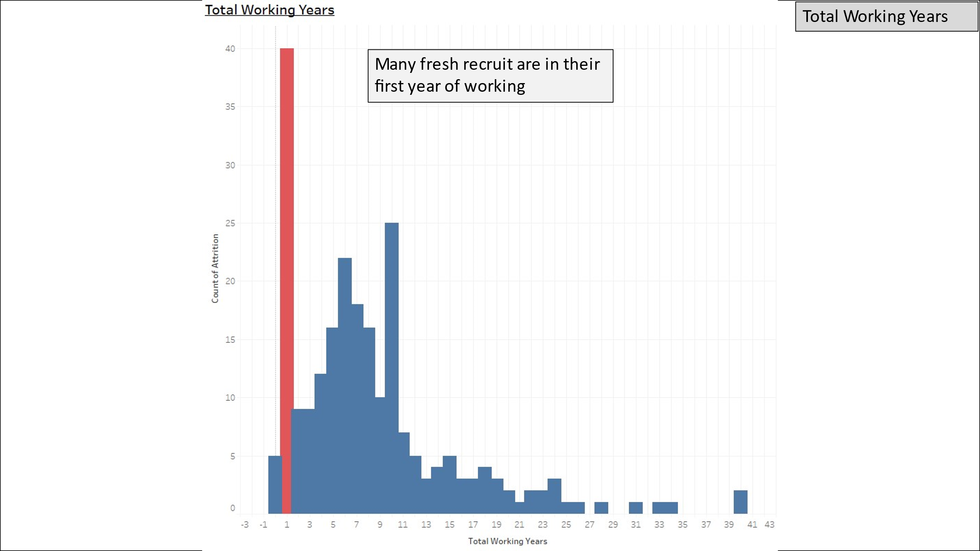

Figure 2 Chart of distribution of total working years

Figure 3 Distribution of Job Role

Colour has the ability to convey an information and emotion based on its colour. Red colour is often associated with an alarming situation, blood or injury and green colour associated with good things. We have utilized it to connect our visual chart with the possible emotion of our audience.

Figure 4 is discussing about the strength of Company A which is its outstanding work-life balance score, or index based on the survey. The value 3 not the best value but it is showing that Company A has done well to provide a good work-life balance working environment to the employee. This information should be good news to the policy maker or Head of HR department as they have done a great job and able to connect to the information that we are providing. Other example is Figure 3, we are using red color to demonstrate alarming emotion for audience to focus on the top 3 job role that contribute to 70% of the attrition.

Figure 4 Work-life balance score of Company A

Variation of colour can also be used to demonstrate variation in category. Figure 5 shows a pie chart with different colour. This is to provide the relative comparison if not exact percentage of the attrition rate distribution.

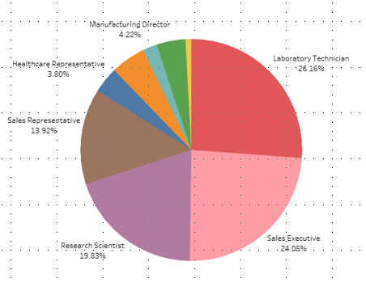

Figure 5 Distribution of Job Role

## Length

The traditional bar graph is the method that is both the least complicated and the most transparent when comparing different categories. The standard bar graph is comprised of a number of individual bars whose lengths range from one another. Referring to Figure 4, we are using X- axis to present the category of score and Y- axis to present the number of attritions. This type of chart usually used to present a relative difference between categories.

## Direction

To demonstrate direction, we use line chart. Line charts, also known as line graphs, are effective visual tools that can be utilized to illustrate patterns in data collected over a period of time or a specific correlation. One axis of the graph may represent a variable value, while the other axis typically displays a timeline of events. In our case, we are using line charts to present a trend or direction of total revenue of Company A as shown in Figure 1. In our chart, we can see the rise in revenue from year 2010 to 2019 is slower compared to the drop during 2019 to 2022.

We use X-axis to present timeline and Y-axis to present the total revenue. We can see that the progression of the line shows whether the chart is going upward or down. The direction help viewer to determine nature of the chart based on the title. Adding the timeline into the consideration, we can use it to show information changes over time by looking at the gradient and approximately comparing it in different timeline.

## Angle

When it comes to visually comparing the various components of a whole, the easiest and most effective method is to use pie charts. A pie chart, for instance, can be used to compare a variety of budget allocations, population segments, or responses to questions about market research in a quick and efficient manner. Figure 5 shows an example of implementation of pie chart in our study. The pie chart presents a proportion of job role with its angle or portion size relative to its attrition percentage. With this, audience are able to quickly understand that part of the pie takes the most portion compared to other part or vice versa.

## Position

Basic scatter plot used dots to represent value for two different variables. The viewer should be able to determine the magnitude of the value by how far the the dots from the axis line. However, scatter plot are not often used to analyse a specific dot, instead it was used to analyse a group of dot or in a layman’s term, to classify.

Figure 6 Monthly income distribution

The scatter plot in Figure 6 was used to classify a less ideal monthly income correspond to their years at company and total working years. Having a lower salary while having more working experience is not an ideal situation, thus resulting in them leaving for another job. Now whether the employee come for a raise or not, as a good employer or manager, we should consider a relatively higher salary for higher working experience individual.

## Other Visual Cues

To promote better direction of explanation and analysis. We provide some annotation of explanation of each slide. This annotation is brief yet very helpful to the viewer. Figure 7 explain about the attrition rate based on how many years specific employee has been in the company. Here we explain our finding and our inference to help the viewer understand a little better.

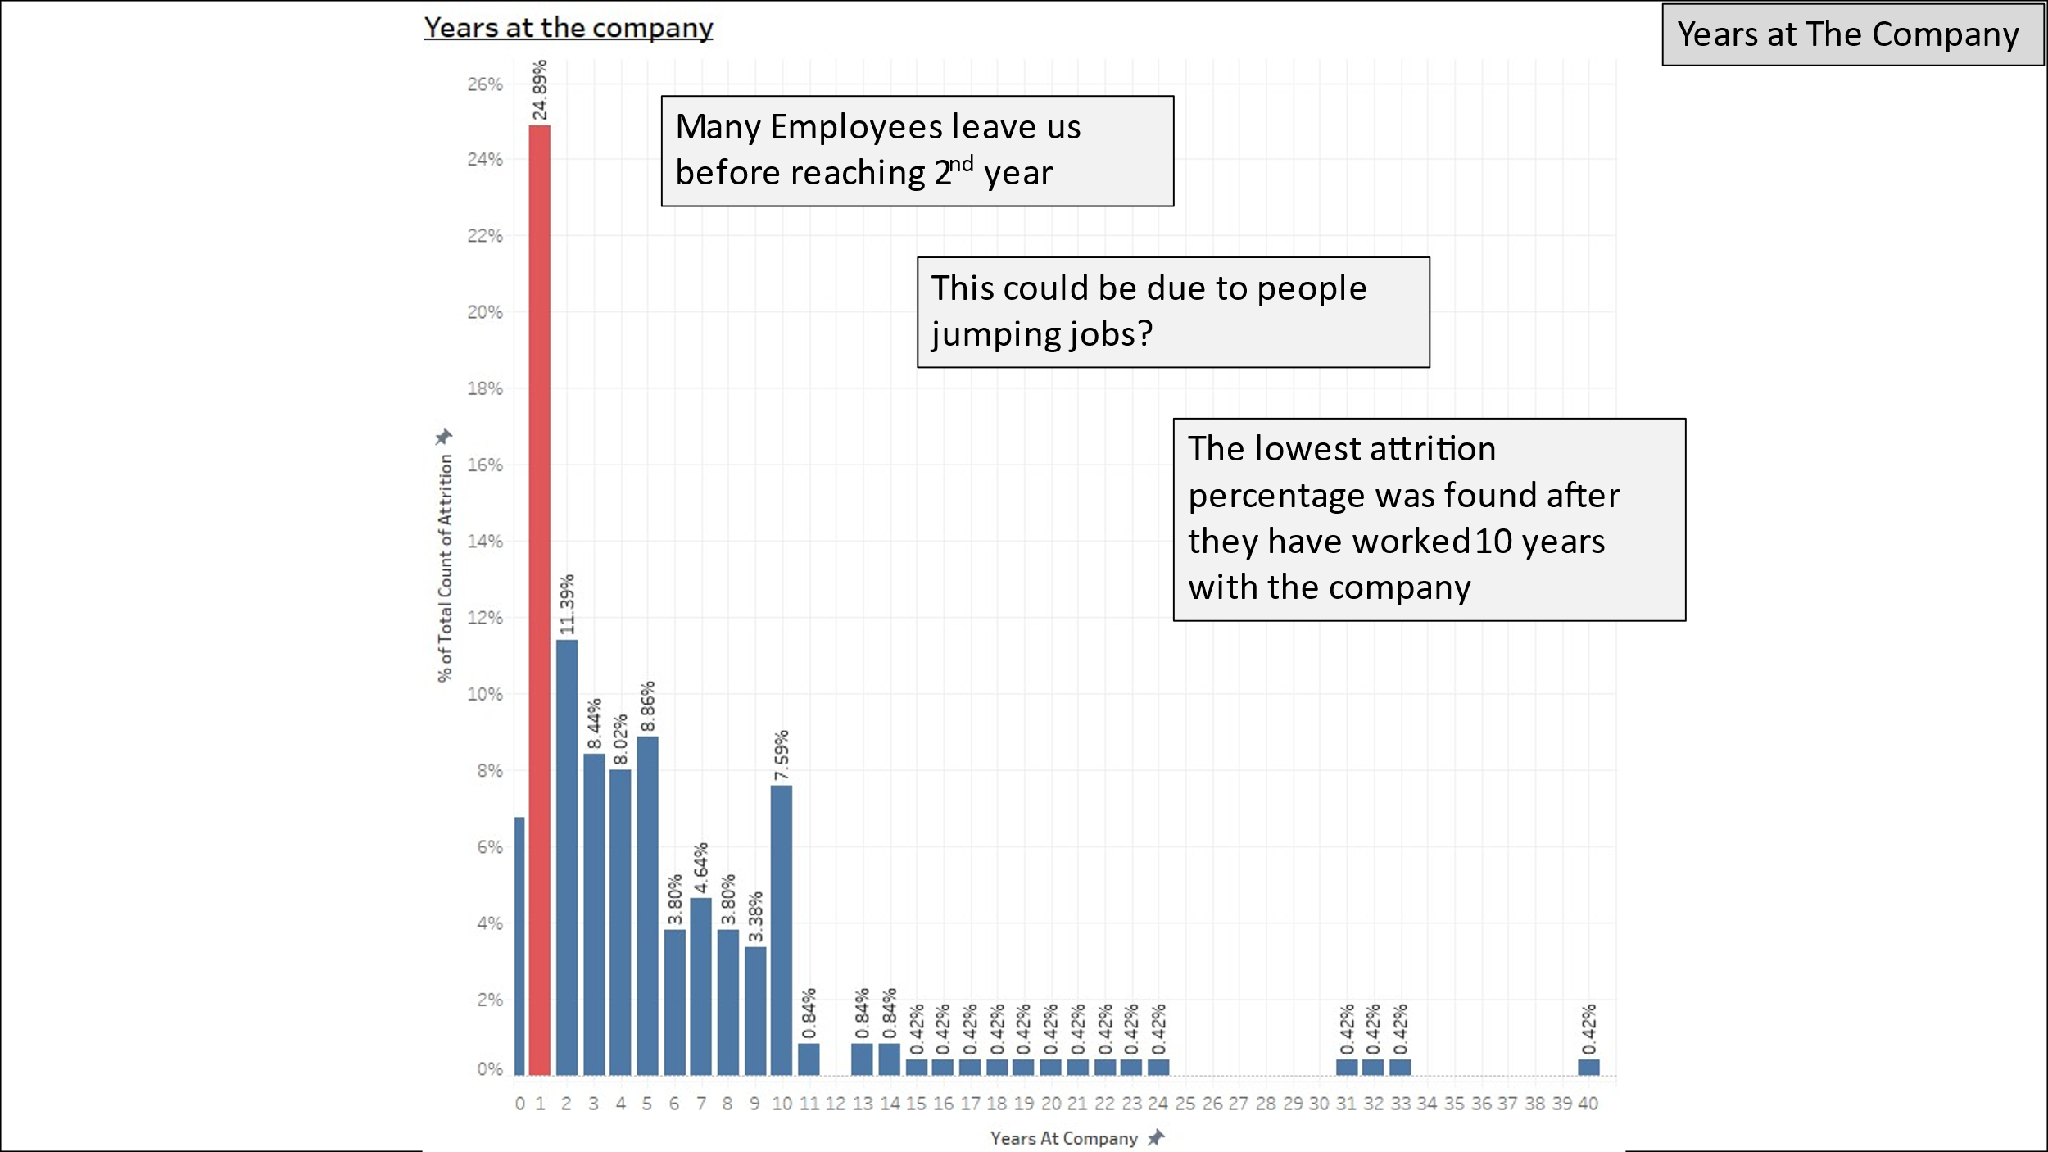

Figure 7 Figure of distribution of years at the company

Other than that, timeline is one of the visual cues. We use vertical timeline with the year ascending as the line going downward. This is to simulate the action of scrolling the timeline as it is one of the action we used to do as a continuation of reading from a browser.

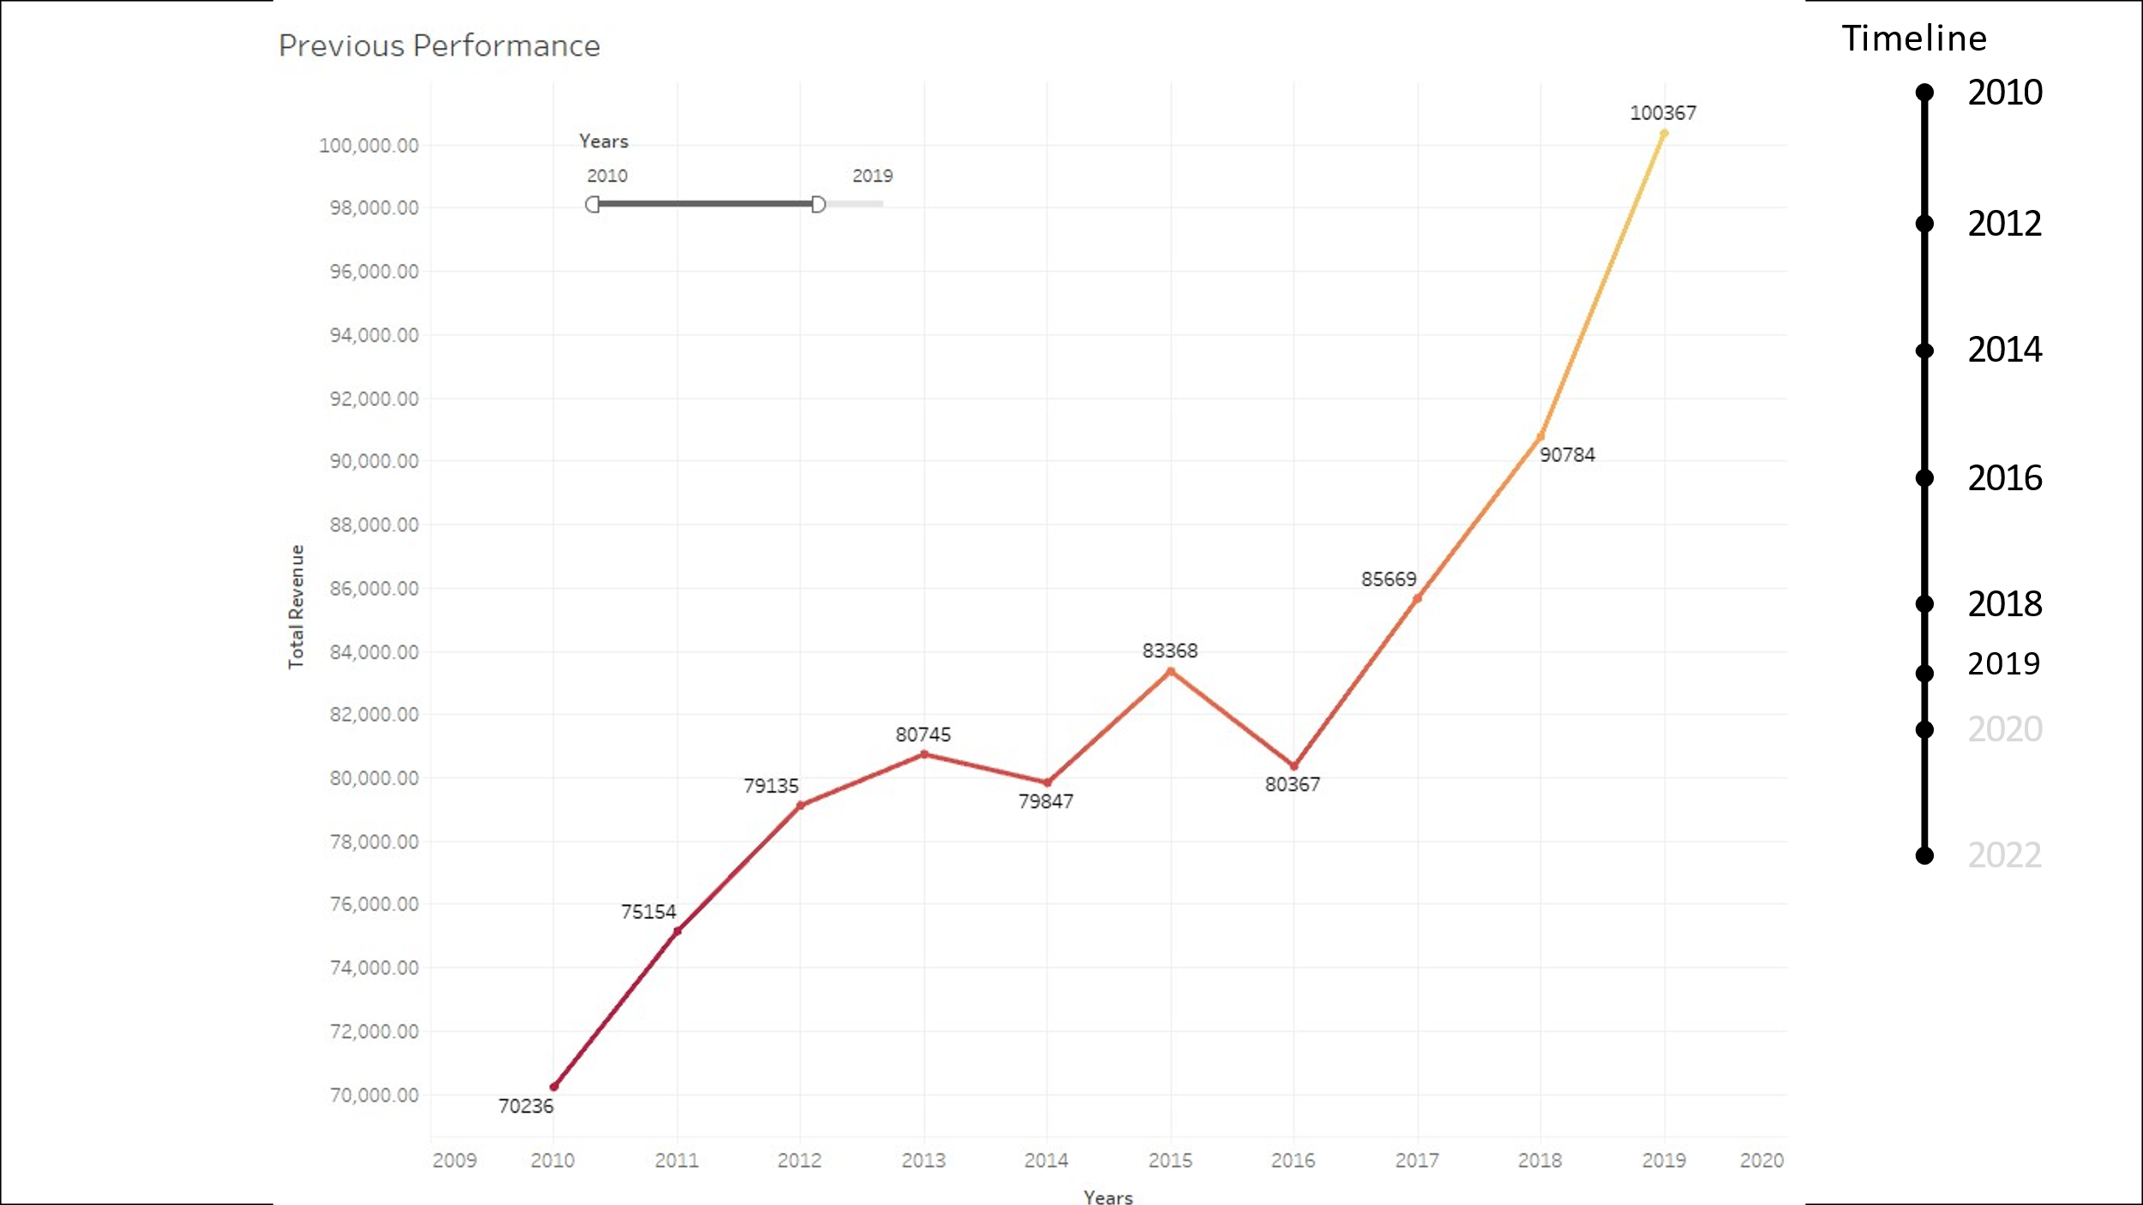

Figure 8 Previous performance of the company

Lastly, other than legend for each chart, we also provided outline slide to ensure the viewer are not lost in the slides. We can see in the Figure 7 that there is text at the top right corner of the slide indicating which part of the presentation are the viewer in.

# Visualisation Discussion

## Visual 1

Figure 9 Previous performance of company

Figure 9 discusses the trend of Company A’s total revenue trend. In this visualization, the timeline chosen was 2009 to 2022 recording the critical phase where the value is having its peak and going back to the support area which is around 70 000. The

The type of chart chosen in to present this data is line chart as line chart is a good method to present a value against a time frame. In this case, the colour of the line does not represent anything other than the value of total revenue itself. Even though the colour can be used to represent something else, this is the only data we have for this chart. Here we can see the colour change to lighter colour as the value reaches its peak.

Here we can see the black line with year at the side as a timeline for this story/issue. Here we are discussing about the trend of the total revenue, having the timeline changing with irregular range, we prepare a timeline showing the current focus timeline as darker black, while showing the other timeline, as greyish colour as shown in Figure 8. We proposed the timeline as if it is a scrolling bar to make viewer feel a bit familiar with the method.

## Visual 2

Figure 10 Monthly income distribution

Figure 10 discusses one of the factors on the increase of company’s attrition which is monthly income. The main highlight of this visualization is that the bottom left side of the chart. To focus on that, we zoom in and filter out unnecessary data by placing a boundary which is average line. This direct the user to see that specific item.

Figure 11 Zoomed Monthly income distribution

## Visual 3

Figure 12 Job Role distribution

Figure 13 Job Role distribution top 3

Visual in Figure 12 and Figure 13 discuss about the percentage of attrition by each job role. Each job role has different attrition rate, and, in the chart, we highlight the top 3 job role which total up to 70%. The top 3 job role will be the focus of the next analysis or the next action that will be taken depending on how the discussion during the meeting if there is one. It is already clear enough that there is three big pie pieces but to ensure that the three is being the discussion topic in this visualization, we group the three parts of the pie and change the colour to red representing “caution”

## Visual 4

Figure 14 Job involvement and years at company distribution

Visual in Figure 14 discuss about the distribution of attrition in relative to their job involvement and their working years with our company. We use bar chart to present the number of years they are working with us and colour hue to present their job involvement index. Darker colour of red reflect to higher job involvement index. This visualization is to investigate if the freshies are being bullied to do work more than what they are supposed to. The result is they not really obvious as there is more senior employee think they are involving more than the junior employee.

## Visual 5

Figure 15 Monthly income distribution against attrition

Figure 15 discusses about the monthly income distribution comparing it between employee who leave versus who stayed. Here we used box plot to demonstrate the distribution. Removing most of the text or annotation on the plot give a much cleaner look and allow the viewer to focus on the number which is the mean of the distribution. As the lower quartile and higher quartile are not discussed, we remove them from the visualization. The aim of this visualization is to compare the monthly income distribution among the employee who leave the company and employee who stayed to make an inference on the possible reason of attrition. Having to know the information, we can do further investigation on specific job role, or the higher up management.

# Conclusion

This data is very straight forward, and information is easy to deliver. Major part of the data is to measure the distribution to figure out which factor is the problem and which part of the company is the problem. Implementation of visual cues are easily done without any inconsistency as the data’s outlier stands out among other information. Using visual cues to direct the viewer to look at the point of the discussion creates a more readable and easier to analyze visualization and reducing the amount of time to catch the info.

# Reference

Pavansubhash (2017). IBM HR Analytics Employee Attrition and Perofrmance. https://www.kaggle.com/datasets/pavansubhasht/ibm-hr-analytics-attrition-dataset/code